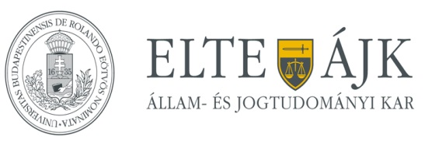

6th Comparative Law Workshop
“The principle of legal certainty from a comparative perspective”
Budapest, Hungary
23 November 2018 (Friday)

co-organizers:
Eötvös Loránd University (ELTE) Faculty of Law
University of Florence, Law Department (PhD Programme in Legal Sciences)

Workshop venue:
ELTE Law Faculty, 1053 Budapest, Egyetem tér 1-3.
Room ‘Kari Tanácsterem’ (ground floor)

9.00-9.30 Opening

Chair: Balázs Fekete (co-organizer, ELTE Faculty of Law)

Alessandro Simoni (Head of the PhD Programme in Legal Sciences, University of Florence)
Katalin Kelemen (co-organizer, Örebro University School of Law, Psychology and Social Work)

9.30-10.45 Section I: Judicial Approaches

Chair: Alessandro Simoni

The judge and the legality principle in criminal law. A comparative overview of the Italian experience
Alberto Cappellini (PhD candidate, Law Department, University of Florence)

The obligation to reason a judgment and the standard of proof required for in civil law proceedings regarding causal connection
Mónika Csöndes (PhD, Assistant Professor, Corvinus University of Budapest, and senior advisor at the Curia of Hungary)

10.45-12.00 Section II: Constitutional Law Approaches I

Chair: Katalin Kelemen

Legal certainty - an immanent element of human rights?
Márton Matyasovszky-Németh (PhD candidate, ELTE Faculty of Law)

Constitutionalization of human rights and the principle of legal certainty in the European civil law systems
Milica V. Matijević (PhD, Law Department, University of Florence)

12.00-13.00 Lunch

13.00-14.15 Section III: Constitutional Law Approaches II

Chair: Katalin Kelemen

The Uncertain Boundary. Constitutional Limits to the Primacy of EU Law vis-à-vis the Safeguarding of the Effectiveness of Supranational Law
Daniele Pellegrini (PhD candidate, Law Department, University of Florence)

Legal certainty during transition periods in the practice of the Hungarian Constitutional Court
Emese Szilágyi (Junior Research Fellow, Hungarian Academy of Sciences Centre for Social Sciences)

14.15-14.45 Coffee break

14.45-16.00 Section IV: Conceptual Approaches

Chair: Balázs Fekete

Pluralism as an alternative to the ‘one-way view’ of legal certainty
Felipe Pante Leme de Campos (PhD candidate, Law Department, University of Florence)

Legal certainties: Towards a plural understanding of legal certainty
Lakshmi Gopal (Lecturer, Martin Luther University of Halle-Wittenberg)

16.00 Closing

Participation is free upon registration, please register at fekete.balazs@ajk.elte.hu.

The Workshop is part of the actions supported by the Italian Ministry of Education, University and Research following the recognition of the DSG as Department of Excellence.

